**WHAT IS THE ESCAPE FILES?**

The *escape files* is a practical and complete guide for building customisable and educational escape games in folder format. You, the educator/builder, can create your own educational escape games for your students/players to enjoy, by following a series of simple steps and picking and choosing your puzzles. All you require is some basic computer skills, a printer, an ordinary folder and an envelope. The guide comes complete with all the other materials to create endless possibilities. Building and preparing the game can be done within an afternoon. The game can be played with up to five players or be played with the whole class by dividing the class into smaller groups. The players will hone their 21st century skills by unravelling mysteries, solving puzzles and working together. The puzzles are varied and fun for all learning styles and ages (starting from 11). Anyone can play!

**HOW TO PLAY?**

The players are given a folder containing material for several puzzles and a closed envelope. The folder either also contains instructions and an introduction or the teacher will introduce the game and explain the rules. The goal of the game is to find the answer to a question: the players have to deduct something about a game character, organism, object or location. To help them answer this question they can use an overview of the game characters, a venn diagram or a map that comes with the folder. The players will also need several clues to answer the question. They get these by solving the puzzles that are in the folder. Each puzzle will give them a unique and essential clue. Once the players have solved all the puzzles they can deduct who, what or where they are looking for. When they agree on the answer, they may open the envelope which contains the correct answer to the question and the conclusion to the story. The players can then reflect on their (learning) experience. The teacher might help them by asking them about their experiences, how they worked together and how they solved the puzzles.

**HOW TO BUILD?**

Building is easy and relatively quick. By following six steps you’ll be guided through the process, making all kinds of choices along the way. You won’t have to come up with fanciful stories, intriguing puzzles or overarching structures: that has already been taken care of. The only thing you really have to consider is what the players you have in mind will enjoy the most playing and what you fancy building. If you are a more experienced (puzzle) maker, you can of course alter or bolt on any elements to your liking, but we advise not to strain too far from the six steps. Here is an overview of the steps:

1 picking the theme

2 deciding on the question

3 picking the puzzles

4 deciding on the conclusion

5 building the puzzles

6 finishing up

**START BUILDING!**

1 PICKING THE THEME

The first step is picking a theme for your escape folder. *Escape files* has at its core four themes to choose from. Pick one you and the players you have in mind will enjoy the most. This choice will not affect your options for the question or puzzles later on. You can choose from:

deepsea hard-fi  
 a more realistic approach to the sci-fi genre, this game is set in the near future  
 on the bottom of the deepsea in the first abyssopelagic research center

empty streets  
 a game set during a zombie apocalypse caused by an infectious brain fungus

fantasy crusade

an epic fantasy game about conflict and a quest to find a sacred grail in faraway  
 desert land

pirates of the north

a cold and salty game about a fabled pirate captain and his search for a golden  
 city somewhere on the north pole

When you’ve chosen your theme, download and print the corresponding front. This is an image of the title you can use for the front of the folder. You can cut it and glue it to a plain folder or craft a paper seal from it.

2 DECIDING ON THE QUESTION

The second step is to decide on the question you want the players to answer in the end. Independently of the theme you went for during step 1, you can choose from three types of questions: ‘who’, ‘what’ and ‘where’.

If you pick ‘who’, the players have to deduct which of four game characters has commited murder, who is infected, who will be king/queen, who is the traitor, etcetera. The clues they’ll get will be pieces of information about the characters, leading to the answer. To aid the players, there will be a helpful overview of the game characters included in the folder.

If you pick ‘what’, the players have to deduct what plant, creature or object satisfies certain descriptions, which will be the clues they’ll get. To aid the players, there will be a venn diagram included in the folder.

If you pick ‘where’, the players have to deduct a certain location on a map, using coordinates. The numbers they need for this, will be the clues. To aid the players, there will be a map included in the folder.

When you’ve chosen a question, you can decide on the introduction for the players. For each combination of theme and question there is a premade premise, a story for the players, which conveys the theme and their quest. You can copy this, adjust this or write your own, and choose to either include it in the folder or introduce the game some other way (verbally for instance).

3 PICKING THE PUZZLES

During the third step you get to decide which puzzles you want to include, but you’ll also have to decide how many puzzles you want to include. You can go with two up to five puzzles. Including more puzzles will make the game last longer and make it somewhat more complex. Including more puzzles will also make the game more appealing for a bigger group of players.

There are a total of 12 puzzles to choose from, though the puzzles are not all suitable for every type of main question. That’s why there are three lists of puzzles: one with the compatible puzzles for ‘who’, one with the compatible puzzles for ‘what’ and one with the compatible puzzles for ‘where’. They are listed by the type of talent they appeal to. (They are listed by the main talent, since some puzzles may appeal to multiple types of talent.) For every type of player to be on equal footing, to be able to contribute and have fun, we advise you pick a diverse set of puzzles, with puzzles that appeal to all types of talents.

WHO

linguistic puzzles

cryptography puzzle

the players have to decipher a text in a strange script

snippets puzzle

the players have to put back together a torn up message

spacial puzzles

grille puzzle

the players have to combine a seemingly unimportant text with a grille (a sheet

of paper with a number of small holes)

visual puzzles

stitching puzzle

the players have to trace out a ‘stitching code’

natural puzzles

classification puzzle

the players have to classify an organism with the help of a key

social puzzles

asking puzzle

the players have to ask a specific person about the clue

WHAT

linguistic puzzles

crossword

the players have to answer the questions of a crossword

cryptography puzzle

the players have to decipher a text in a strange script

spacial puzzles

grille puzzle

the players have to combine a seemingly unimportant text with a grille (a sheet  
 of paper with a number of small holes)

rolling puzzle

the players have to roll some sort of imaginary die over a path and figure out on  
 which face it would land

visual puzzles

mirror puzzle

the players have to use a mirror to decipher some strange symbols

perspective puzzle

the players have to make use of perspective to decipher an elongated text

stitching puzzle

the players have to trace out a ‘stitching code’

social puzzles

asking puzzle

the players have to ask a specific person about the clue

WHERE

linguistic puzzles

crossword

the players have to answer the questions of a crossword

cryptography puzzle

the players have to decipher a text in a strange script

mathematical puzzles

gear puzzle

the players have to line up a set of linked gears by turning them a certain number  
 of ticks, all in their heads

spacial puzzles

grille puzzle

the players have to combine a seemingly unimportant text with a grille (a sheet  
 of paper with a number of small holes)

rolling puzzle

the players have to roll some sort of imaginary die over a path and figure out on  
 which face it would land

visual puzzles

mirror puzzle

the players have to use a mirror to decipher some strange symbols

perspective puzzle

the players have to make use of perspective to decipher an elongated text

stitching puzzle

the players have to trace out a ‘stitching code’

natural puzzles

paleontology puzzle

the players have to identify a prehistoric creature from a piece of their skeleton

social puzzles

asking puzzle

the players have to ask a specific person about the clue

4 DECIDING ON THE CONCLUSION

Before you can start building the puzzles, you’ll have to know what their answer is. You’ll have to know the clue they give. Therefore you need to decide what the conclusion to the game is. And that’s what step 4 is all about. The answer depends on the type of question, so go to the section that belongs to the type of question you chose and continue from there:

WHO

The best stories are about people. Have a look at the 20 images of possible characters. You’re going to have to pick four of them for your story. Your premise gives the players a quest to deduct which one of these four characters has commited murder, is infected, will be crowned, is the traitor, etcetera. Download the conclusion to the story (possibly adjusting it or writing your own) and make the four characters you’ve picked more alive by coming up with some information about them. What kind of information you will give the players is up to you, but, at the bare minimum, come up with a name, a role and a little bit of background story for them. Draw the outlines now. You can fill in the details as you work on the conclusion. You might also tell the players about their age, place of birth, personality, hobby, favourite things, etcetera. Use a text editor of your choice to create a character sheet for each of the four characters (something like the next image) and, of course, choose who did/is it, somebody that you think fits your conclusion. His/her name will be added to the envelope.

The clues will be pieces of information about the characters, that together, and only together, lead to the right conclusion. We will put these clues together. Order your four characters and number them 1 to 4. Make sure the one who did/is it, ends up being number 3. Think of three types of information that you want the players to discover about some of your characters. These are things you won’t include in your character sheets and you can’t tell by looking at the character’s image. It can be the place they were just before the murder happened. It can be their blood type. It can be their favourite animal. It can be where they went on holiday last summer. Or it can be the name of their sword. Pretty much anything that you think fits in with the theme goes. Number these three types of information with roman numerals: I, II, III. (If you’ve

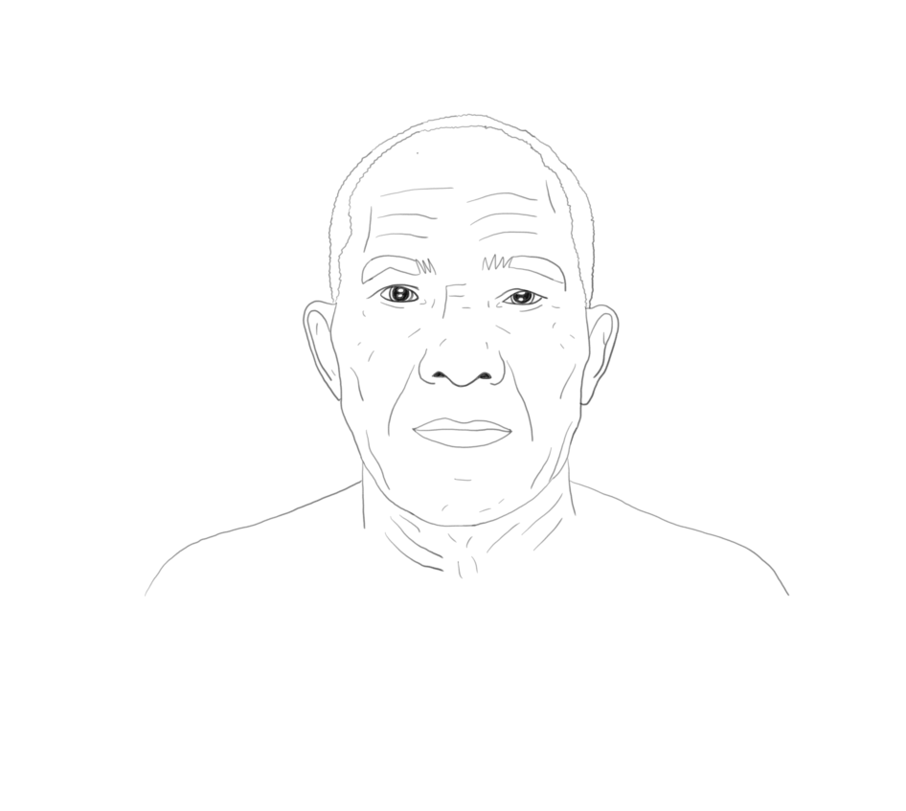

name: Sir Masakazu  
age: 61

place of birth: Yama Machi

role: Knight of Embers

personality: quiet, kind, imaginative, passionate, artistic, determinded, empathetic, helpful

background: Has studied the blade his whole life, mastering both swordplay and craft, but  
 prefers doing bakery. His merveilleux is a real killer.

included the classification puzzle to your puzzle set, make sure you leave information III open for now. In that case we will return to that when building the classification puzzle.)

Now decide what information I of person 1 is, for instance ‘in the kitchen’. The first clue will be something like: ‘Dr Rogers was in the kitchen when the murder happened’. Don’t worry about information I of the characters yet.

Then decide what information II of person 2 is, for instance ‘AB+’. The second clue will be something like: ‘Collins has blood type AB+’.

Decide what information III of person 3 is, for instance ‘manta ray’. (Make sure this lines up with your conclusion.) The third clue will be something like: ‘Dr Brown’s favourite animal is the manta ray’. (You will need this clue and the next three, even if you’ve chosen for a set of two puzzles. Only if you’ve included the classification puzzle to your puzzle set, you can skip this clue, but you’ll still have to make the next ones.)

Decide what information I and II of person 3 are, for instance ‘in the storage room’ and ‘O-’. You won’t tell the players that this information belongs to person 3, only that these two pieces of information belong to the same person. The fourth clue will be something like: ‘somebody was in the storage room when the murdered happened, they scratched themselves and left a drop of blood, which tested to be O-’.

The fifth clue will be similar to the fourth, but this time you don’t have to come up with something. You just have to combine information II and III of person 3. So the fifth clue will be something like: ‘a collection of pictures of manta rays was found in the dark room, the person who was developing these must have cut themselves on the paper, because some blood stains were found on the pictures, they tested to be O-’. (If you’ve included the classification puzzle to your puzzle set, you better hold off on this clue for the moment and return to making it, when you’re building the classification puzzle.)

The last clue will be the fact that whoever did/is it, information I of person 3 belongs to them. You don’t tell the players this information belongs to person 3 of course. The last clue will be something like: ‘the murder happened in the storage room, the murderer must have been there when the murder happened’.

What will actually become the clues leading to the right conclusion, depends on how many puzzles you’ve decided to include in the folder.

If you’ve gone for a set of two puzzles (otherwise you best skip this paragraph), the two clues will be the fourth and fifth one. The others will be given to the players at the start of the game ‘for free’. You can include them in your premise, add the information to the characters sheets or write them down and add these clues to the folder. One of your puzzles will now have the fourth clue as the outcome and one puzzle will have the fifth clue as the outcome.

If you’ve gone for a set of three puzzles (otherwise you best skip this paragraph), the three clues will be the third, the fourth and the fifth one. The others will be given to the players at the start of the game ‘for free’. You can include them in your premise, add the information to the characters sheets or write them down and add these clues to the folder. One of your puzzles will now have the third clue as the outcome, one of your puzzles will have the fourth clue as the outcome, and one puzzle will have the fifth clue as the outcome.

If you’ve gone for a set of four puzzles (otherwise you best skip this paragraph), the four clues will be the second, the third, the fourth and the fifth one. The others will be given to the players at the start of the game ‘for free’. You can include them in your premise, add the information to the characters sheets or write them down and add these clues to the folder. One of your puzzles will now have the second clue as the outcome, one of them will have the third clue as the outcome, one of your puzzles will have the fourth clue as the outcome, and one puzzle will have the fifth clue as the outcome.

If you’ve gone for a set of five puzzles (otherwise you best skip this paragraph), the five clues will be the first five clues. The sixth clue will be given to the players at the start of the game ‘for free’. You can include it in your premise, add the information to the characters sheets or write it down and add this clues to the folder. One of your puzzles will now have the first clue as the outcome, one of them will have the second clue as the

outcome, one of them will have the third clue as the outcome, one of your puzzles will have the fourth clue as the outcome, and one puzzle will have the fifth clue as the outcome.

Decide which outcome will belong to which puzzle. Now you’ve decided on the answers you can print the conclusion to the story and put it in an envelope. It is better to wait til step 6 before you seal the envelope and include it in the folder. You can also print the character sheets and add these to the folder. (If you’ve picked the classification puzzle as one of your puzzles, it is best to do the printing of the character sheets during step 6, since you’re probably going to add something to them.)

WHAT

If you like riddles, you’ve come to the right place. Your premise gives the players a quest to deduct an animal, a plant or an object using a venn diagram. This animal, plant or object will be the answer inside the envelope. You have probably encountered a venn diagram before, but maybe not it’s name. The next image is an example of a venn diagram. You’ll know what it is when you see it. The players will gather clues that tell them where to look in the venn diagram. In the example of the next image a clue could be ‘it has four limbs’ or ‘it’s not terrestrial’. What will become the actual clues leading to the right conclusion, depends on how many puzzles you’ve decided to include in the folder.

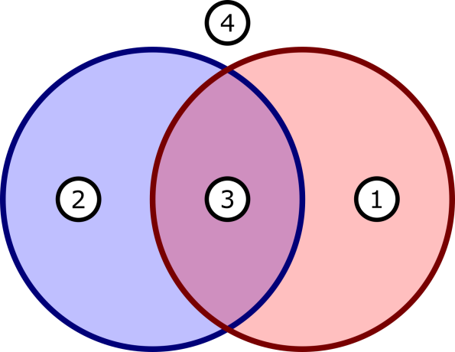

██ has four limbs

██ terrestrial

1 turtle  
2 viper  
3 horse  
4 seahorse

If you’ve gone for a set of two puzzles (otherwise you best skip this paragraph), download the venn diagram for two sets. The venn diagram you will give your players will look a lot like the one in the last image. You can adjust this one using a text editor of your choice to make your own. Your premise will decide wether it’s about an animal, a plant or an object. (If you don’t like that decision, you can of course alter your premise.) You now need to think of two properties that animals/plants/objects can have. (You’ll have to fill in every spot in the venn diagram, so don’t make it hard on yourself by going for a property like ‘can reproduce’.) Fill in the diagram and pick the answer that you think fits with the theme. Write down the two clues that lead to the right answer, just like mentioned before. One of your puzzles will have the first clue as the outcome and the other puzzle will have the second clue as the outcome.

If you’ve gone for a set of three puzzles (otherwise you best skip this paragraph), download the venn diagram for three sets. The venn diagram you will give your players will look a lot like the one in the next image. You can adjust this one using a text editor of your choice to make your own. Your premise will decide wether it’s about an animal, a plant or an object. (If you don’t like that decision, you can of course alter your premise.) You now need to think of three properties that animals/plants/objects can have. (You’ll have to fill in every spot in the venn diagram, so don’t make it hard on yourself by going for a property like ‘can repreduce’.) Fill in the diagram and pick the answer that you think fits with the theme. Write down the two clues that lead to the right answer, just like mentioned before. One of your puzzles will have the first clue as the outcome, one of the puzzles will have the second clue as the outcome and one puzzle will have the third clue as the outcome.

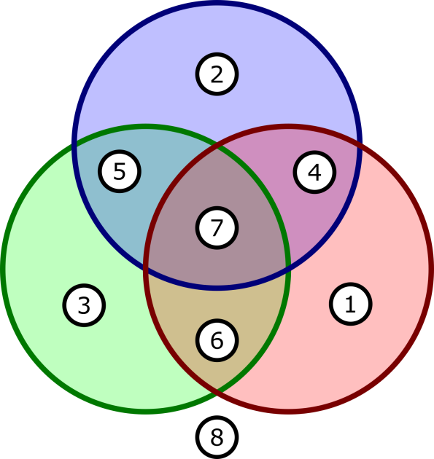

██ red

██ aquatic

██ never grows flowers

1 rose  
2 water lily  
3 spruce  
4 cardinal flower  
5 kelp  
6 yew  
7 red algae  
8 sunflower

If you’ve gone for a set of four puzzles (otherwise you best skip this paragraph), download the venn diagram for four sets. The venn diagram you will give your players will look a lot like the one in the next image. You can adjust this one to make your own. Your premise will decide wether it’s about an animal, a plant or an object. (If you don’t like that decision, you can of course alter your premise.) You now need to think of four properties that animals/plants/objects can have. (You’ll have to fill in every spot in the venn diagram, so don’t make it hard on yourself by going for a property like ‘can repreduce’.) Fill in the diagram and pick the answer that you think fits with the theme. Write down the two clues that lead to the right answer, just like mentioned before. One of your puzzles will have the first clue as the outcome, one of the puzzles will have the second clue as the outcome, one will have the third clue and one puzzle will have the fourth clue as the outcome.

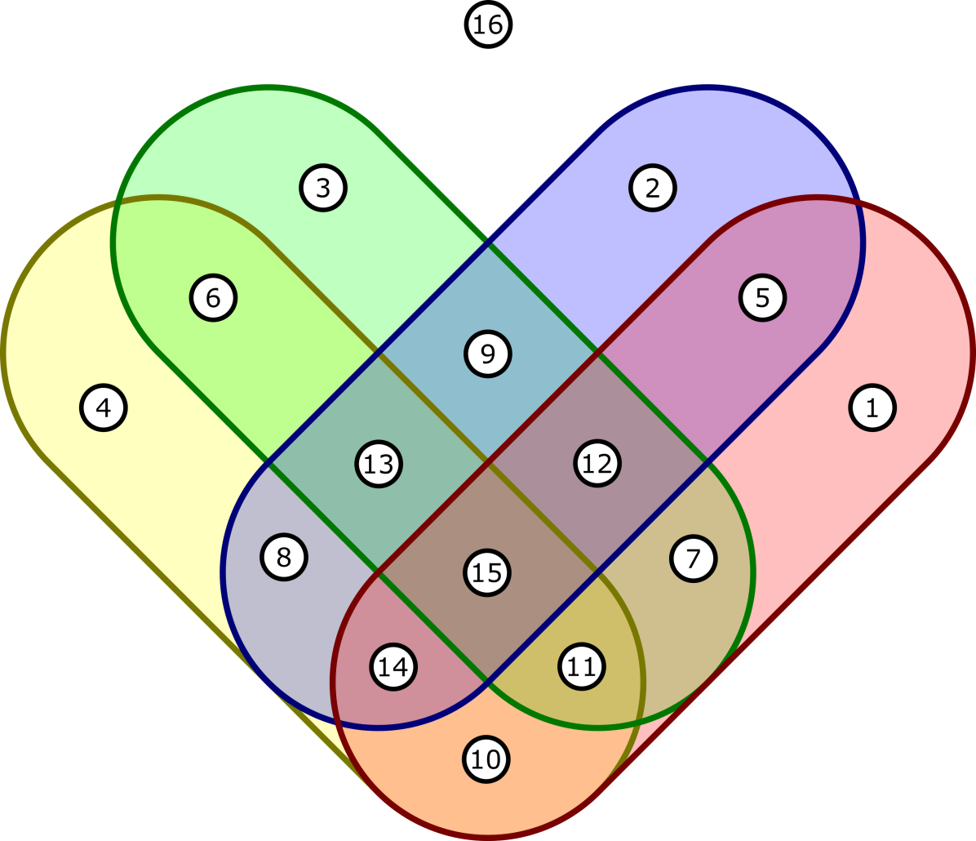

██ edible

██ round

██ flat

██ hard

1 banana 9 sunflower  
2 beach ball 10 baguette  
3 carpet 11 cracker  
4 crystal 12 pancake  
5 apple 13 coin  
6 glass shard 14 walnut  
7 slice of bread 15 biscuit  
8 ring 16 boot

If you’ve gone for a set of five puzzles (otherwise you best skip this paragraph), download the venn diagram for five sets. The venn diagram you will give your players will look a lot like the one in the next image. You can adjust this one using a text editor of your choice to make your own. Your premise will decide wether it’s about an animal, a plant or an object. (If you don’t like that decision, you can of course alter your premise.) You now need to think of five properties that animals/plants/objects can have. (You’ll have to fill in every spot in the venn diagram, so don’t make it hard on yourself by going for a property like ‘can repreduce’.) Fill in the diagram and pick the answer that you think fits with the theme. Five properties can be a bit of a challenge. So make sure you choose a subject you’re comfortable with. In the next image you can see that we too had to fill in some not very well known animals. This, though, may open the opportunity for your players to use the internet and learn something about, say a prehistoric creature. Write down the two clues that lead to the right answer, just like mentioned before. One of your puzzles will have the first clue as the outcome, one of the puzzles will have the second clue as the outcome, one will have the third clue, one will the fourth clue, and one puzzle will have the fifth clue as the outcome.

Decide which clue will belong to which puzzle. Now you’ve decided on the answers you can download and print the conclusion to the story (possibly adjusting it or writing your own), and put it in an envelope. It is better to wait til step 6 before you seal the envelope and include it in the folder. You can also print the venn diagram and add it to the folder.

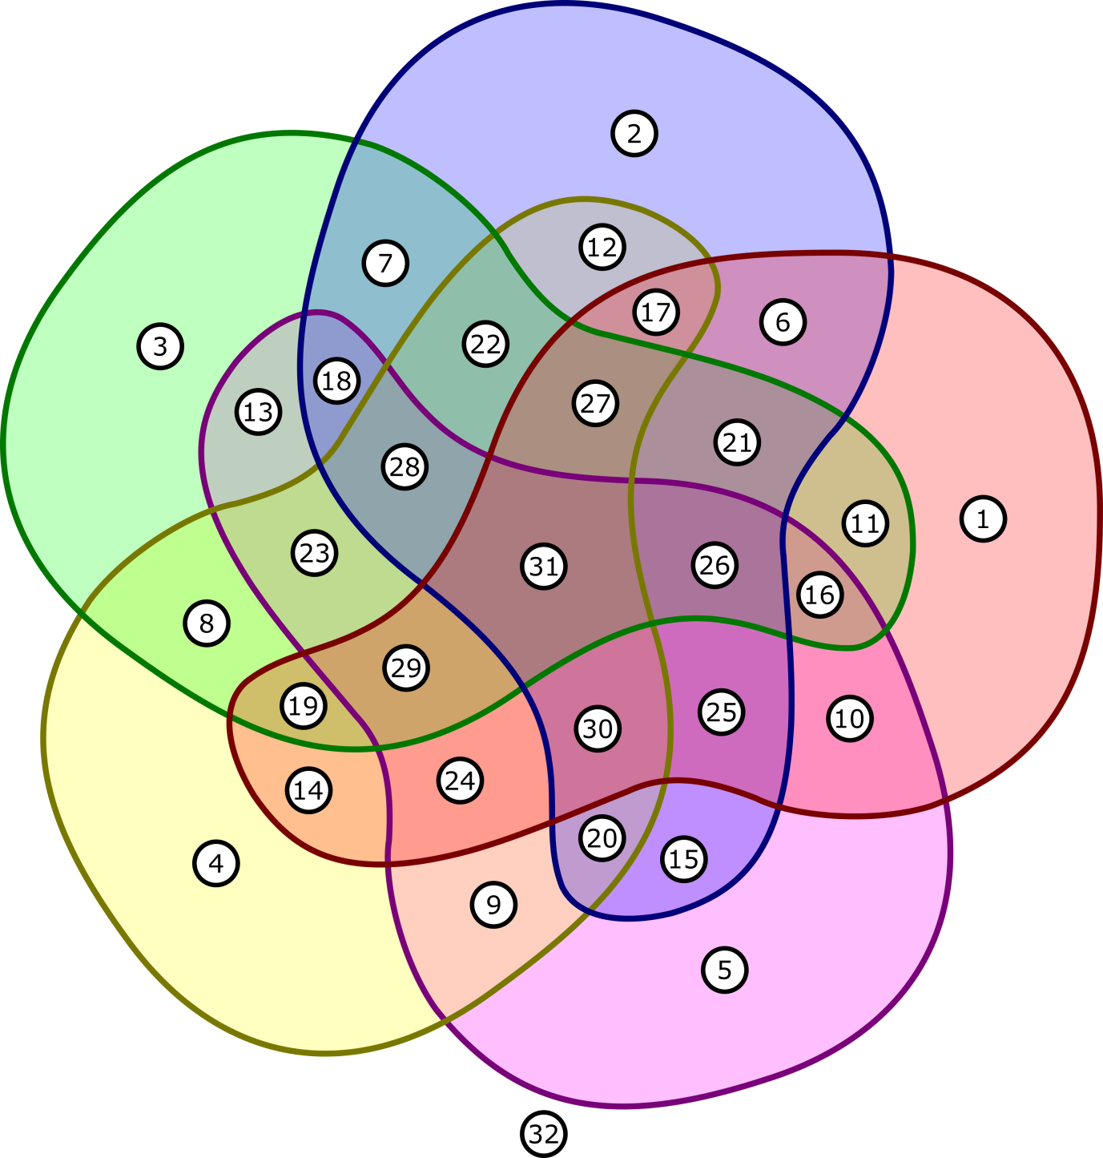

██ cannot lay eggs

██ extinct

██ aquatic

██ carnivorous

██ walks on four legs

1 kangaroo 17 leptictidium  
2 pachycephalosaur 18 atopodentatus  
3 surgeonfish 19 dolphin  
4 owl 20 dimetrodon  
5 tortoise 21 steller's sea cow  
6 giant sloth 22 mosasaur  
7 trilobite 23 aligator  
8 shark 24 lion  
9 komodo dragon 25 mammoth  
10 elephant 26 moeritherium  
11 manatee 27 basilosaur  
12 tyrannosaur 28 spinosaur  
13 marine iguana 29 otter  
14 bat 30 sabre tooth  
15 brachiosaur 31 ambulocetus  
16 hippo 32 butterfly

WHERE

Maps are the best! Start off by downloading the map that belongs to your theme. Your premise gives the players a quest to pinpoint a place on this map using the coordinates they found. Pick a spot on the map that you think fits your conclusion to the story, somewhere in the middle where the grid lines cross. The coordinates of this spot will be the answer that goes into the envelope. What will become the clues leading to this spot, depends on how many puzzles you’ve decided to include in the folder.

If you’ve gone for a set of two puzzles (otherwise you best skip this paragraph), the two clues will be the horizontal and vertical coordinate of the final answer. So one of your puzzles will have the horizontal coordinate as the outcome and the other puzzle will have the vertical coordinate as the outcome. (Take a look at the next image. It will help.) Decide which coordinate will belong to which puzzle and make sure you mark this puzzle accordingly once you’ve finished building it in step 5 and before it goes into the folder (by drawing a big X on the puzzle for instance).

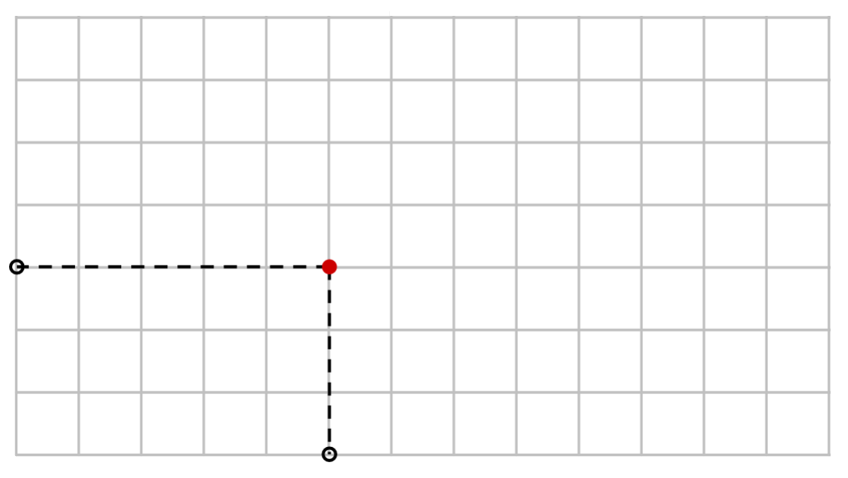

If you’ve gone for a set of three puzzles (otherwise you best skip this paragraph), you have to find a slanted line that goes through the final answer. (Take a look at the next image. It will help.) Make sure this slanted line goes through at least two other spots where the grid lines cross. If you fiddle around a bit you can pretty much always find such a slanted line. Remember two of these spots: let’s call them A and B for now. Your three clues will be the coordinates of A, the coordinates of B and the horizontal coordinate of the final answer. So one of your puzzles will have two numbers as the outcome (the coordinates of A), one of your puzzles will also have two numbers as the outcome (the coordinates of B) and one puzzle will have one number as the outcome (the horizontal coordinate of the final answer). Decide which outcome will belong to which puzzle and, when there are two numbers as an outcome, make sure it is clear which is the horizontal and which is the vertical coordinate when building the puzzle in step 5 (by drawing a big X on the puzzle for instance).

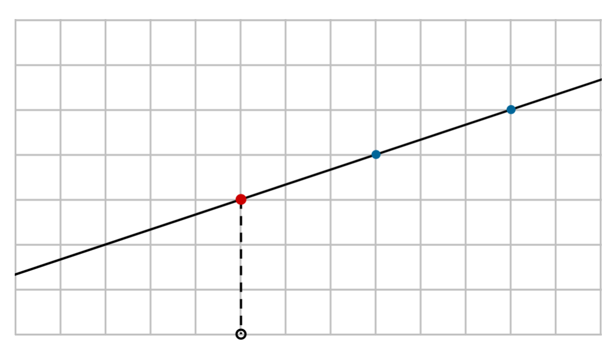

If you’ve gone for a set of four puzzles (otherwise you best skip this paragraph), you have to start on the final answer and walk a number of steps (say M steps) to the right and a number of steps (say N steps) either all up or all down. You can decide what numbers M and N are (they can be the same) and whether you walk up or down. Let’s call the place you’ve ended up A for now. (Take a look at the next image. It will help.) Now start again on the final answer and walk M steps to the left. If you went up before, you now go N steps down. If you went down before, you now go N steps up. Let’s call the place you’ve ended up B for now. The final answer should be bang in the middle of A and B. Your four clues will be the horizontal coordinate of A, the vertical coordinate of A, the horizontal coordinate of B and the vertical coordinate of B. So one of your puzzles will have the horizontal coordinate of A as the outcome, one of your puzzles will have the vertical coordinate of A as the outcome, one of your puzzles will have the horizontal coordinate of B as the outcome and one of your puzzles will have the vertical coordinate of B as the outcome. Decide which outcome will belong to which puzzle and make sure you mark this puzzle accordingly once you’ve finished building it in step 5 and before it goes into the folder (for instance by drawing a big green X on one puzzle, a big green Y on another, a big yellow X on a third and a big yellow Y on the fourth).

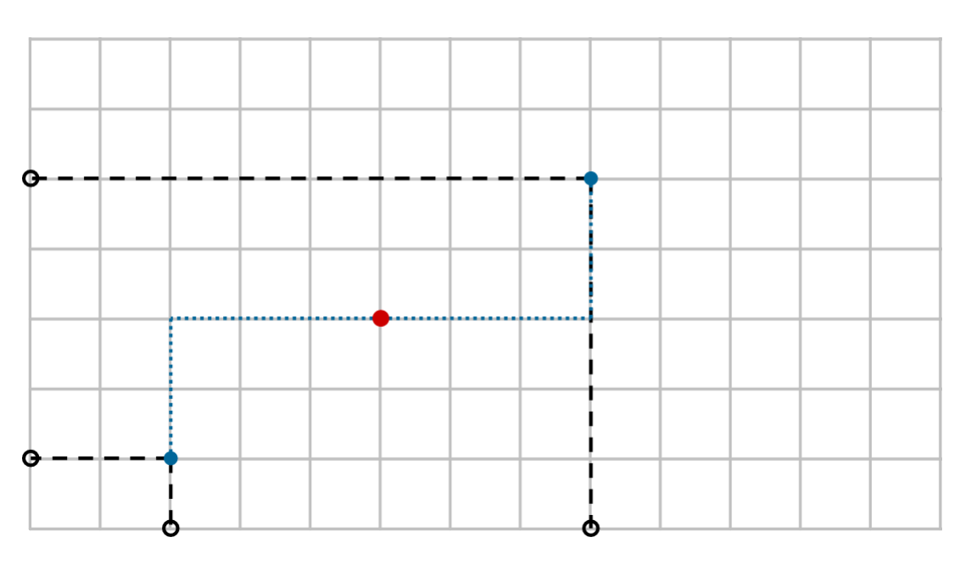

If you’ve gone for a set of five puzzles (otherwise you best skip this paragraph), you have to find a slanted line that goes through the final answer. (Take a look at the next image. It will help.) Make sure this slanted line goes through at least two other spots where the grid lines cross. If you fiddle around a bit you can pretty much always find such a slanted line. Remember two of these spots: let’s call them A and B for now. Your five clues will be the horizontal coordinate of A, the vertical coordinate of A, the horizontal coordinate of B, the vertical coordinate of B and the horizontal coordinate of the final answer. So one of your puzzles will have the horizontal coordinate of A as the outcome, one of your puzzles will have the vertical coordinate of A as the outcome, one of your puzzles will have the horizontal coordinate of B as the outcome, one of your puzzles will have the vertical coordinate of B as the outcome and one of your puzzles will have the horizontal coordinate of the final answer as the outcome. Decide which outcome will belong to which puzzle and make sure you mark this puzzle accordingly once you’ve finished building it in step 5 and before it goes into the folder (for instance by drawing a big green X on one puzzle, a big green Y on another, a big yellow X on a third and a big yellow Y on the fourth).

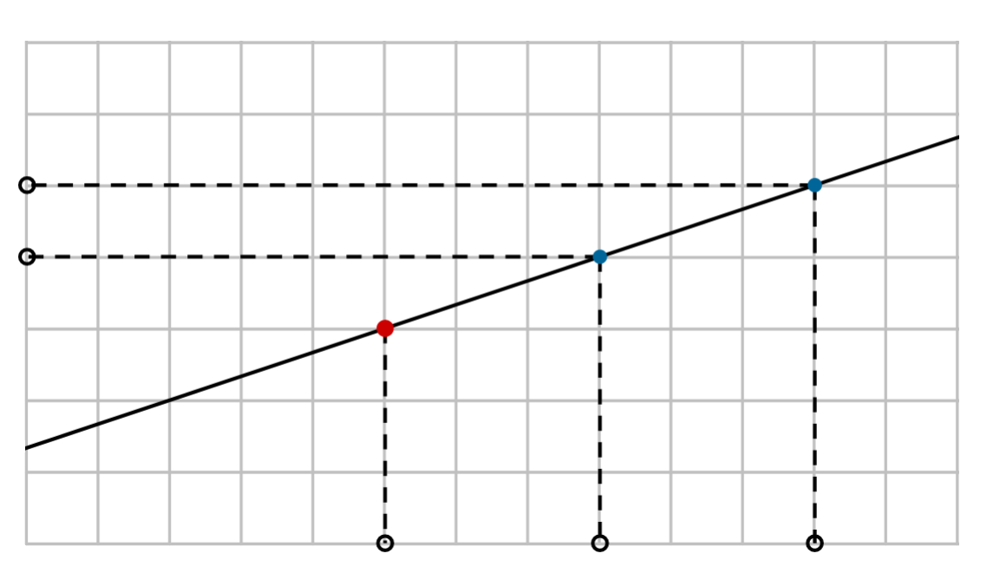

Now you’ve decided on the answers you can download and print the conclusion to the story (possibly adjusting it or writing your own), and put it in an envelope. It is better to wait til step 6 before you seal the envelope and include it in the folder. You can also print the map and the example for the players, and add these to the folder.

5 BUILDING THE PUZZLES

Now it’s time to put the puzzles together. Each puzzle has its own instructions, tips and tricks:

asking puzzle

This puzzle does not require any material, but does require you get an accomplice involved, someone who is available during the playing of the game to answer simple questions from the players, preferably not you or any of the players. Put a little note, saying ‘ask X about Y’ (X being the person and Y being the clue the players need) in the folder and you’re done. (You can upgrade this puzzle by not mentioning the accomplice’s name, but by hinting at them through the means of a little riddle, like ‘the one with the big, blue bike’, but this does require you and the players to know this accomplice very well.)

classification puzzle

This puzzle is centered around a key. We have found some great ones online, but you could also use a book if you have one or your own website.

This is the link to the key for plants:  
<https://gobotany.nativeplanttrust.org/simple/>  
This is the link to the key for birds:  
<https://www.rspb.org.uk/birds-and-wildlife/wildlife-guides/identify-a-bird/>

This is the link to the key for feathers:  
<https://www.fws.gov/lab/featheratlas/idtool.php>  
This is the link to the key for bugs:  
<https://www.insectidentification.org/bugfinder-start.php>

Whichever key you use, make sure you also hand it to your players, either by referring to it somewhere in the folder or by handing it to them at the start of the game. (If you choose the key for bugs mentioned above, make sure you also tell the players which state the bug is from.) Pick a plant/bird/feather/bug/… that will be the answer to this puzzle. (We did this simply by going through the key randomly and then picking a plant/bird/feather/bug/… we liked.) Now go to google-images (or you can use bing I guess) and google a nice, clear image of this plant/bird/feather/bug/…, an image that would fit in with your theme. Sometimes the key itself has good images too. Take this image and use your text editor of choice to write the name of the plant/bird/feather/bug/… next to it, together with the names of three similar plants/birds/feathers/bugs/… (You can use the key to easily find similar ones.) Now write a little hint next to the image, like in the next four examples. (We’ve also included the source of the image, since it’s not ours.) Print it and include it to the folder.

In Dr Brown’s cabin grows a little tree.  
You’ve got one of it’s leaves, but you’re  
not sure what it is. It could be one of  
these possibilities:

tulip tree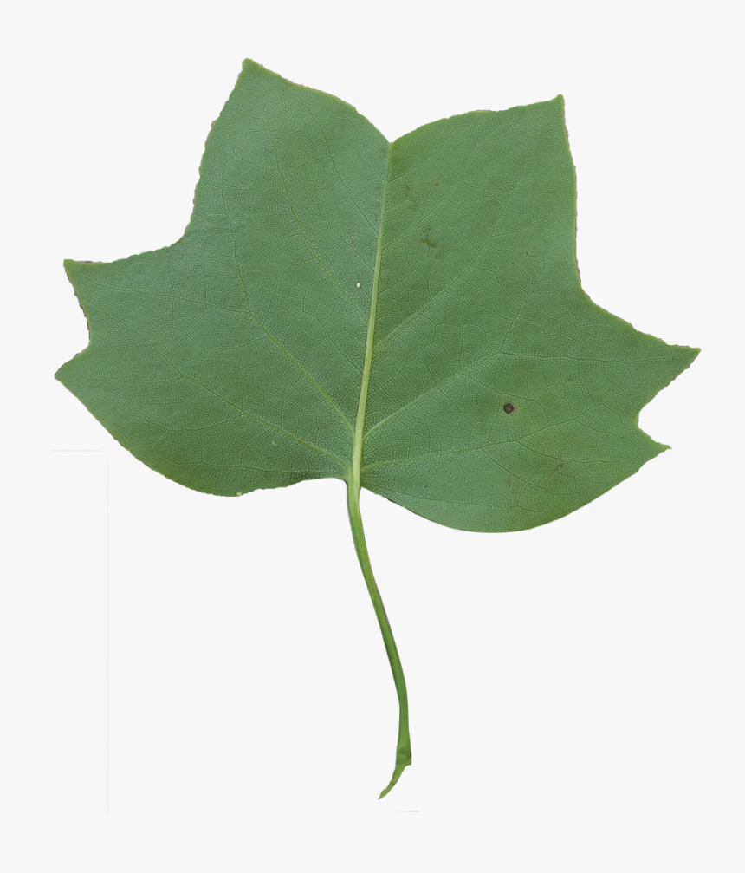

striped maple

foxgrape

prickly gooseberry

(Copper Kelly, from pngitem.com)

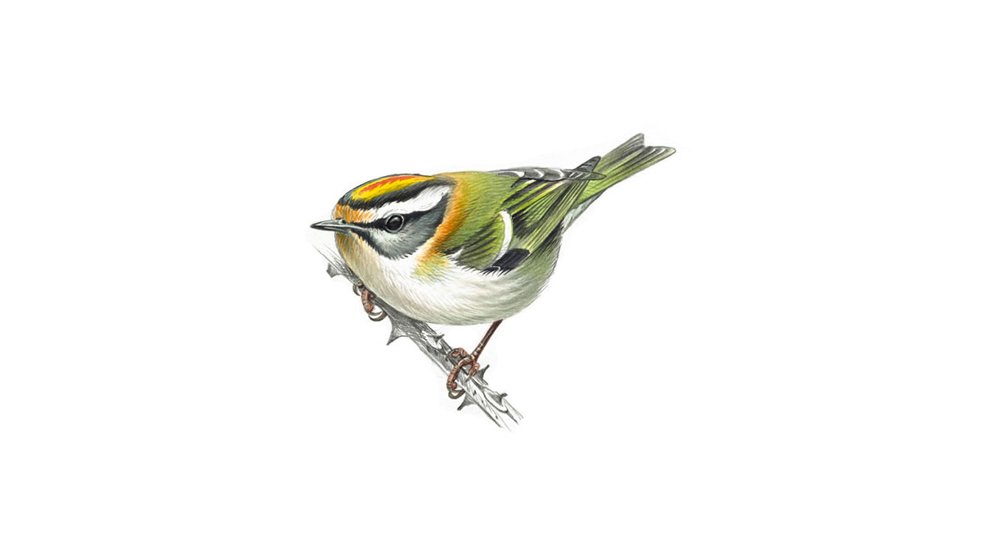

You’ve found a bird drawing in Dr Brown’s room.  
You vaguely remember her loving a certain bird  
Species. Which one was it? The firecrest?

Or was it the golden oriole? It could be the  
greenfinch. Maybe the willow warbler?

(from rspb.org.uk)

You found feathers in Dr Brown’s room.  
You don’t remember her having a pet.  
The DNA-scanner thinks it’s of one of the  
following birds:

american kestrel

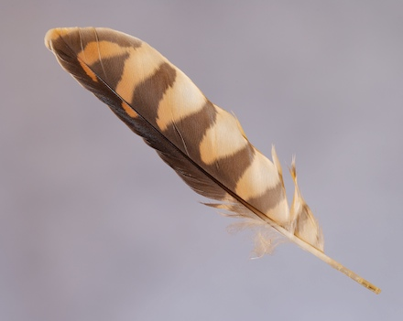redtailed hawk

killdeer

poorwill

(from animalspot.net)

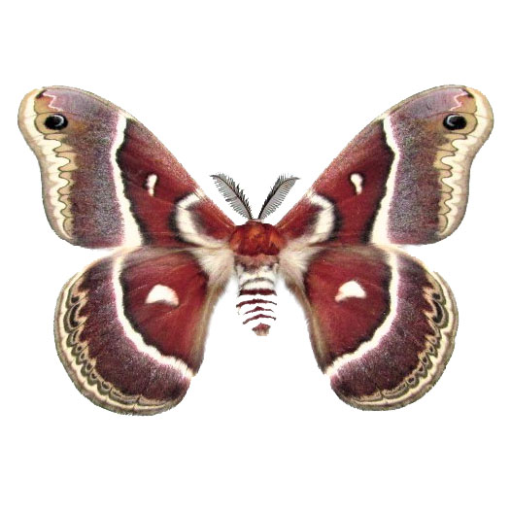Dr Brown collects butterflies. Her  
greatest treasure is this big, red  
one, bigger than your hand. You  
Don’t know the name of it, because  
The name tags in her collection have  
all been jumbled up. You stare at  
Four tags:  
glover’s silkmoth

ilia underwing

herald moth

painted lady  
Which one could it be?

(from bicbugs.com)

crossword

Download and open the crossword example in your spreadsheet editor of choice. Here you see how answering multiple questions can lead to a clue (which in this case is the very unhelpful word ‘example’). You can use this example to make your own crossword. Start by vertically spelling out your clue. Then think of several questions of which the answer contains the letter that contributes to the clue. The questions can be about anything you want. In the example we used some arbitrary quiz questions, but you can ask questions about your favourite subject, or something related to the theme of the game, or something entirely different. Adjust the lay-out to your liking and remove all the answers from the spreadsheet. Print it and include it to the folder.

cryptography puzzle

Open your text editor of choice. Write down the clue in text form, preferably wrapped in a flavoursome text fitting with the theme. The text should be a handful of sentences long. Don’t use capital letters or punctuation. Instead, start every sentence on a new line. Use the find-and-replace-all option to replace every A with a certain symbol. Do the same for every B with a different symbol. Continue until you’ve done every letter of the alphabet. You can use one of the following scripts or assemble your own by scrolling through the special-symbols menu. Use a large font. For some scripts it helps to replace all spaces with a couple of spaces, so it’s easier to see where words start and end. Sometimes it also helps for readability to put a blank line between every line. Print the encoded text once you’re done.

ALCHEMICAL

| A | B | C | D | E | F | G | H | I | J | K | L | M |
| --- | --- | --- | --- | --- | --- | --- | --- | --- | --- | --- | --- | --- |
| 🜊 | 🝁 | ⚸ | 🜖 | 🜕 | ⚳ | ☉ | 🝆 | ⚷ | ♇ | ⚴ | ⚶ | ♁ |

| N | O | P | Q | R | S | T | U | V | W | X | Y | Z |
| --- | --- | --- | --- | --- | --- | --- | --- | --- | --- | --- | --- | --- |
| ♆ | 🜏 | ♄ | ☿ | 🜘 | ☽ | ♃ | ♅ | 🜂 | 🜄 | 🜍 | 🜔 | 🜋 |

BRAILLE

| A | B | C | D | E | F | G | H | I | J | K | L | M |
| --- | --- | --- | --- | --- | --- | --- | --- | --- | --- | --- | --- | --- |
| ⠁ | ⠃ | ⠉ | ⠙ | ⠑ | ⠋ | ⠛ | ⠓ | ⠊ | ⠚ | ⠅ | ⠇ | ⠍ |

| N | O | P | Q | R | S | T | U | V | W | X | Y | Z |
| --- | --- | --- | --- | --- | --- | --- | --- | --- | --- | --- | --- | --- |
| ⠝ | ⠕ | ⠏ | ⠟ | ⠗ | ⠎ | ⠞ | ⠥ | ⠧ | ⠺ | ⠭ | ⠽ | ⠵ |

GEOMETRICAL

| A | B | C | D | E | F | G | H | I | J | K | L | M |
| --- | --- | --- | --- | --- | --- | --- | --- | --- | --- | --- | --- | --- |
| ┐ | ╜ | ╒ | ╕ | ┼ | ╨ | ├ | ╡ | ╥ | ╓ | ╪ | ┌ | ╙ |

| N | O | P | Q | R | S | T | U | V | W | X | Y | Z |
| --- | --- | --- | --- | --- | --- | --- | --- | --- | --- | --- | --- | --- |
| ╖ | ╫ | ╔ | ╘ | ┘ | ┬ | ╤ | ╞ | ┴ | ┤ | ╧ | └ | ╛ |

MATHEMATICAL

| A | B | C | D | E | F | G | H | I | J | K | L | M |
| --- | --- | --- | --- | --- | --- | --- | --- | --- | --- | --- | --- | --- |
| ⫰ | ≡ | ⊞ | ⊗ | ⩛ | ⊕ | ⫯ | ⟓ | ∴ | ⩚ | ⋊ | ∮ | ∝ |

| N | O | P | Q | R | S | T | U | V | W | X | Y | Z |
| --- | --- | --- | --- | --- | --- | --- | --- | --- | --- | --- | --- | --- |
| ⊡ | ⊘ | ⨎ | ⟔ | ⋉ | ≍ | ⟕ | ⦺ | ≎ | ⫱ | ⟖ | ≀ | ⟴ |

ANGULAR

| A | B | C | D | E | F | G | H | I | J | K | L | M |
| --- | --- | --- | --- | --- | --- | --- | --- | --- | --- | --- | --- | --- |
| Խ | Ⱝ | Ѧ | ᕕ | ᚻ | א | Ճ | ⴳ | Ը | ᨅ | Ⱑ | Ꮦ | Պ |

| N | O | P | Q | R | S | T | U | V | W | X | Y | Z |
| --- | --- | --- | --- | --- | --- | --- | --- | --- | --- | --- | --- | --- |
| Ѭ | ᛈ | ᚠ | 𐭿 | ᛗ | Ռ | ᚯ | Ю | ᖾ | ᛯ | Ѫ | ᖽ | Ѩ |

CURLY

| A | B | C | D | E | F | G | H | I | J | K | L | M |
| --- | --- | --- | --- | --- | --- | --- | --- | --- | --- | --- | --- | --- |
| 𐭯 | 𑄈 | ಒ | 𐠦 | ꘫ | Ⰳ | ഖ | ꘪ | ಌ | န | ಟ | ഉ | Ⰾ |

| N | O | P | Q | R | S | T | U | V | W | X | Y | Z |
| --- | --- | --- | --- | --- | --- | --- | --- | --- | --- | --- | --- | --- |
| ꩫ | ᖚ | Ꮝ | ഋ | Ꮸ | ൾ | Թ | ᖗ | Ⰴ | Ⰲ | Ꮡ | ႟ | ड |

EXAMPLE

╤╡╥┬ ╥┬ ┐╖ ┼╧┐╙╔┌┼

╥╤ ╙┐└ ╡┼┌╔ └╫╞ ├┼╤ ┐ ╜┼╤╤┼┘ ├┘╥╔ ╫╖ ╤╡┼ ╥╕┼┐

┐┬ └╫╞ ┬┼┼ ┐ ╒╫╞╔┌┼ ╫╨╨ ┬┼╖╤┼╖╒┼┬ ╥┬ ┼╖╫╞├╡

╥╤ ╥┬ ┼╖╫╞├╡ ╤╫ ╜┼ ┐╜┌┼ ╤╫ ┘┼╒╫├╖╥┬┼ ╔┐╤╤┼┘╖┬

╜╞╤ ╖╫╤ ╤╫╫ ┌╫╖├ ┬╥╖╒┼ ╤╡┐╤ ╙┐╪┼┬ ╤╡┼ ┤╫┘╪ ╤┼╕╥╫╞┬

gear puzzle

Download and print one of the two gear puzzle templates. If your clue consists of two numbers, download and print both, and follow the instructions twice: once for each template. For each of the three smaller gears count the cogs clockwise, around and around, starting from the cog pointed towards the little circle (this is the zeroth cog). Colour the cogs you end on the same colour and colour the littles circles also this colour. Colour all the other cogs a random different colour (but don’t use a colour more than once on the same gear). The next image is an example with the clue 12.

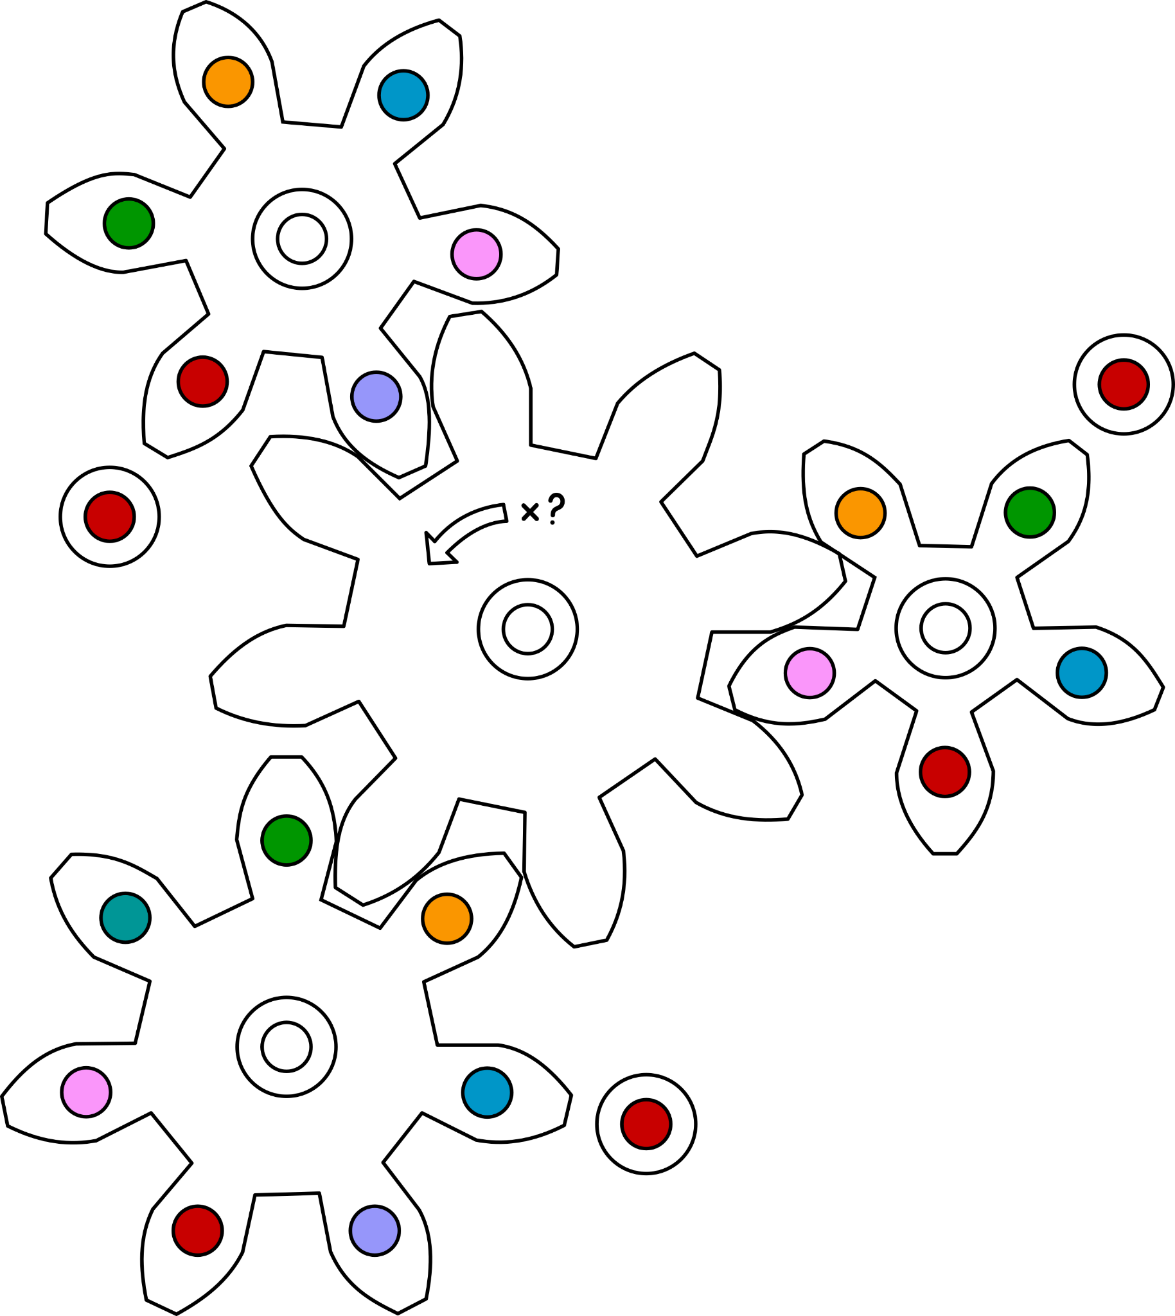

grille puzzle

Open your text editor of choice. Write a flavoursome text fitting with the theme. The text should be about a page long. The font should be somewhat large. You can also use one of the template texts. Important is that you can find all the letters, in order, that spell out your clue. If you can’t, alter the text slightly until you can. Print the text and mark on a different sheet of paper (that’s about the same size as the text) where the important letters are. Cut holes in this paper the size of the letter. Put both sheets of paper in the folder.

mirror puzzle

For this puzzle the players will need to hold a mirror to some symbols to create a readable clue. This means we’ll have to build symbols that produce such text when mirrored. Follow this link: [fontmeme.com/ambigram-font](https://fontmeme.com/ambigram-font/) It will take you to a website that generates ambigrams, something that will be very helpful when it comes to building mirrored images. Enter your clue and select ‘lake reflection’. Choose the biggest font size and select a colour of your liking. Leave ‘effect’ on ‘none’. Press generate and download your image. This now works when you hold a mirror to it. The problem is that it works without the mirror too, and that’s a bit against the spirit of things. Open the image in your image editor of choice (something like paint will do). Select the bottom of each letter/figure and flip it horizontally, like we did with the next example. Print it when you’re done and include it to the folder.



paleontology puzzle

Download the overview, or if your theme is more historic than scientific you can download the overview with alternative names, and have a look at it. Find the number that is your clue. (If you have two numbers you’ll have to follow these instructions twice, once for each number.) Note the name of this prehistoric animal (you can look it up in the ‘normal’ overview for their real name). Then open the folder ‘loose bones’ and go to the bones that belong to your creature. Most of them have multiple images to choose from, so pick one image of bones that you think is interesting for the players you have in mind to identify. Print this image together with the overview (or the alternative overview) and include them to the folder.

perspective puzzle

Open your image editor of choice (something like paint will do) and use the text option to write down your clue. Now stretch this text vertically until it has been completely spaghettified and you can only make out some vertical lines. The text should be completely unreadable, like in the next example. Print this and include it in the folder.



rolling puzzle

This puzzle works with a normal imaginary die, an imaginary tetrahedral die or an imaginary octahedral die. (If you are not a massive nerd like we are and you have never heard the last two big words, you should probably opt for the normal imaginary die and ignore anything we say about the others. The normal one works just fine. Snort.) If you go for the normal imaginary die, you should download and print the square grid template. If you go for one of the others, you should download and print the triangular grid template. If you go for the normal die, also download and print the cube net template. If you go for the tetrahedral die, download and print the tetrahedron net template. If you go for the octahedral die, download and print the octahedron net template.

On the net template, mark one of the faces with the clue. This can be a number, a word, a symbol or a little picture. Mark the other faces with a different number/word/symbol/picture. In your head, place the die on the grid with the face with the clue on it down and let it roll around a bit. Trace out the path it takes. Make sure the path never goes back on itself and never crosses itself. Mark the grid at the end of the path with the markings of the face that is down when the die has reached the end. Put both the grid and the net into the folder. If you have a normal, tetrahedral or octahedral die, you can speed up this proces by literally rolling out the path. The next tips might otherwise help.

A normal die marked like the left image has options to roll as shown in the right image. (For instance when 1 is down and you roll forwards the 5 will be down.)

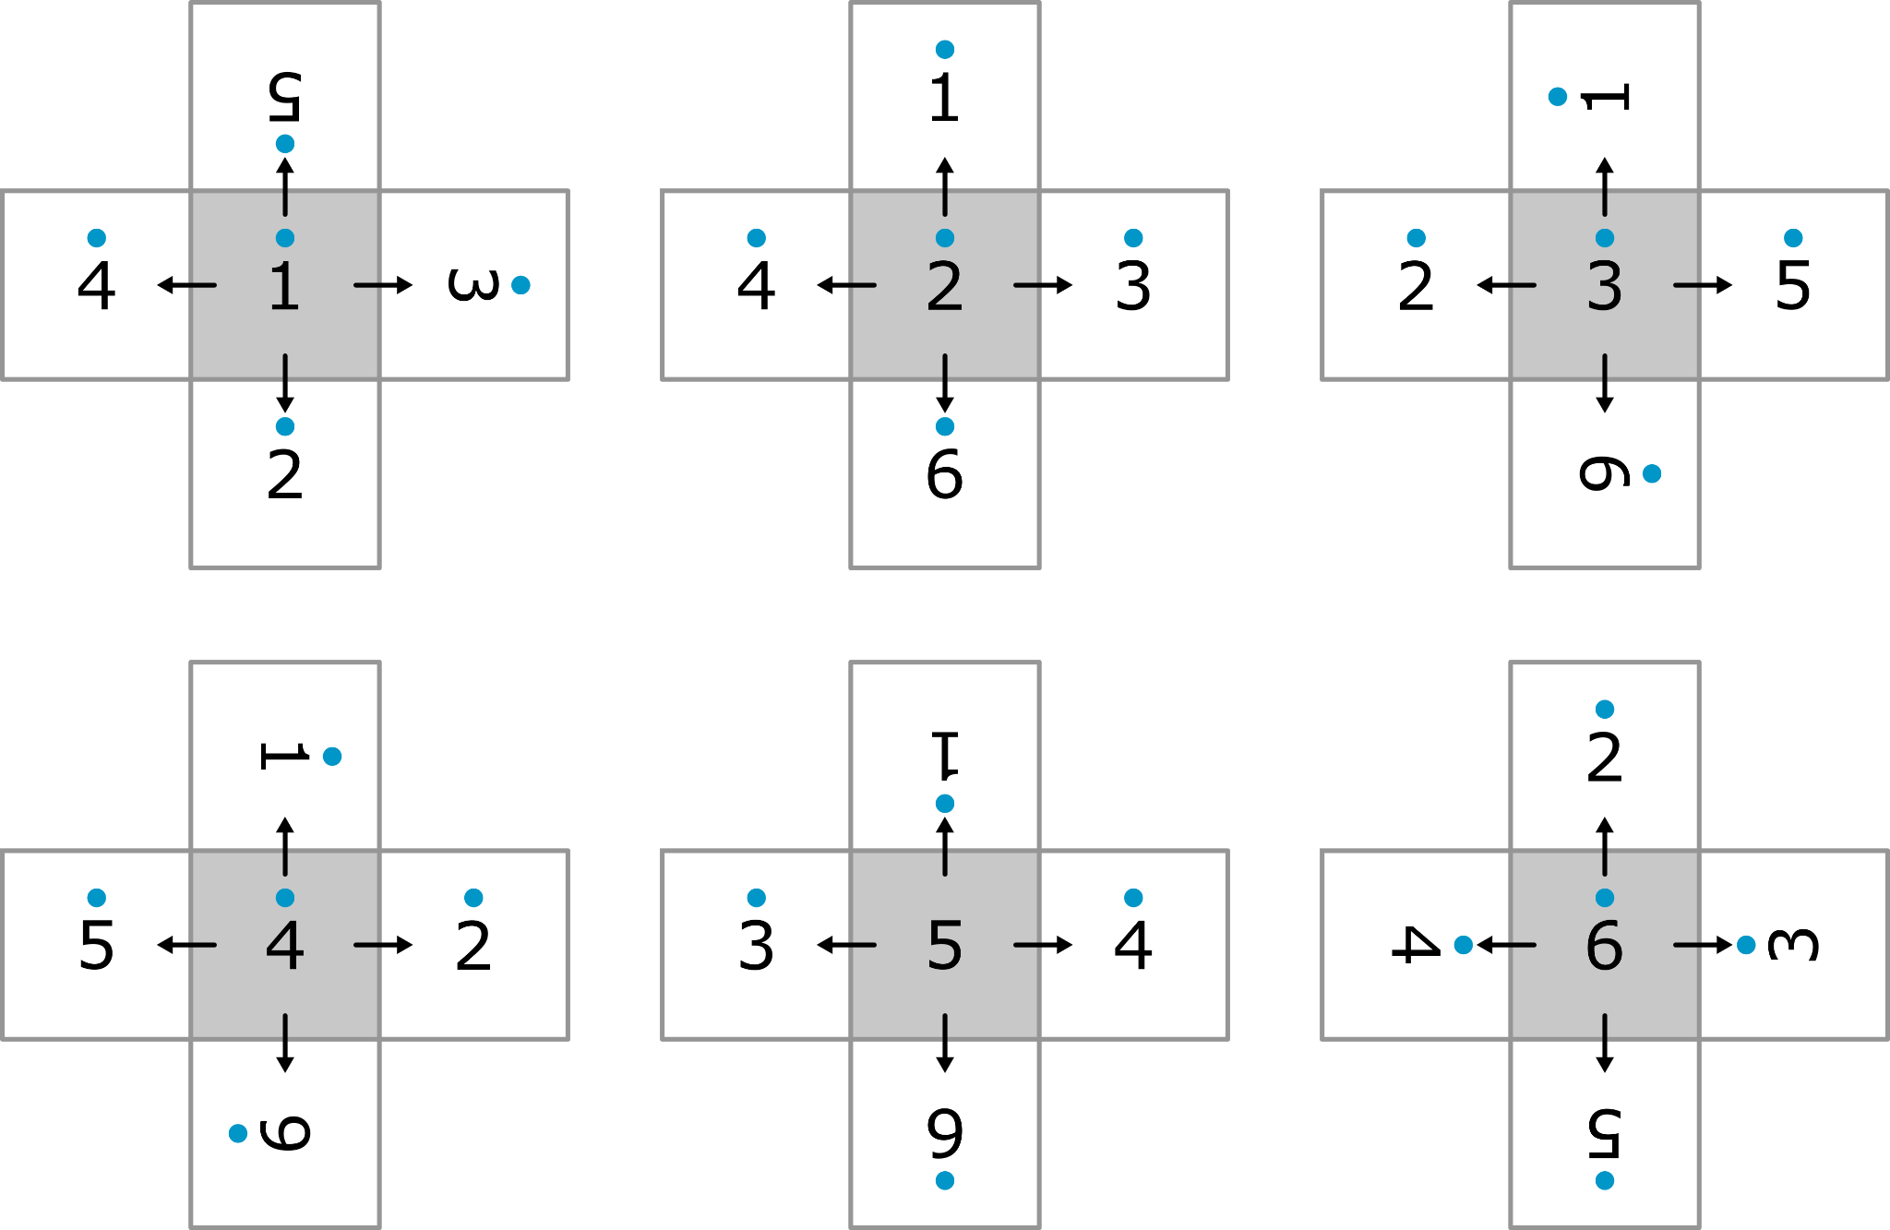

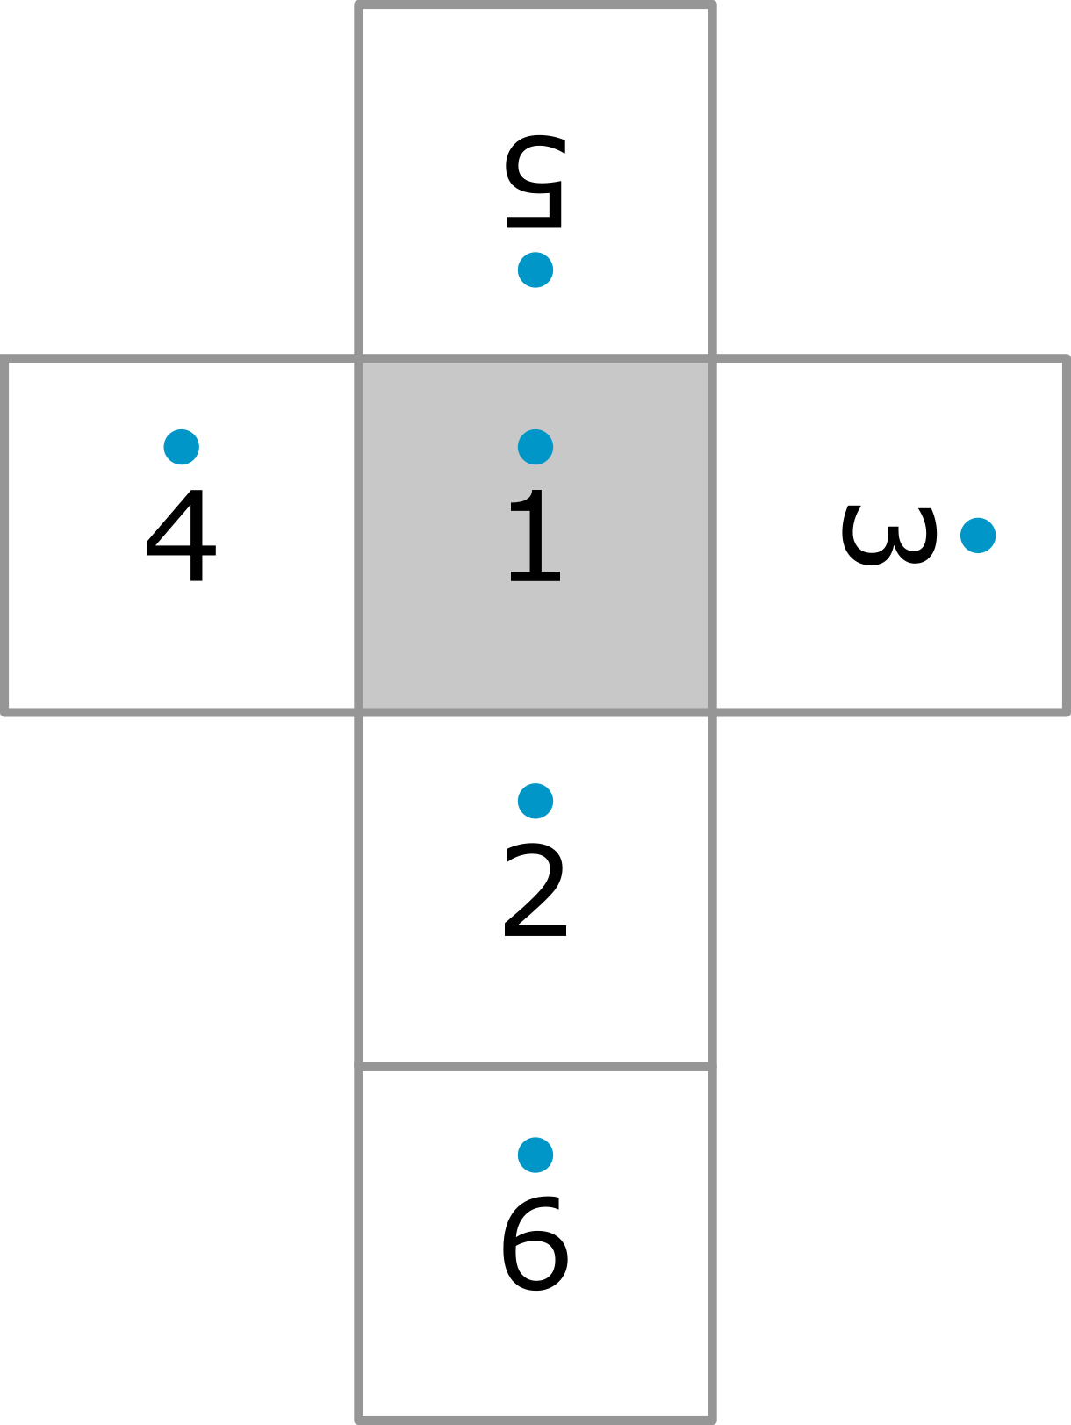

The path of a tetrahedral die is very predictable. A tetrahedral die marked like the left image will always roll according to the pattern of the right image (imagine the pattern continues simulary in all directions). It doesn’t matter how you roll, the pattern will always be the same with a tetrahedral die.

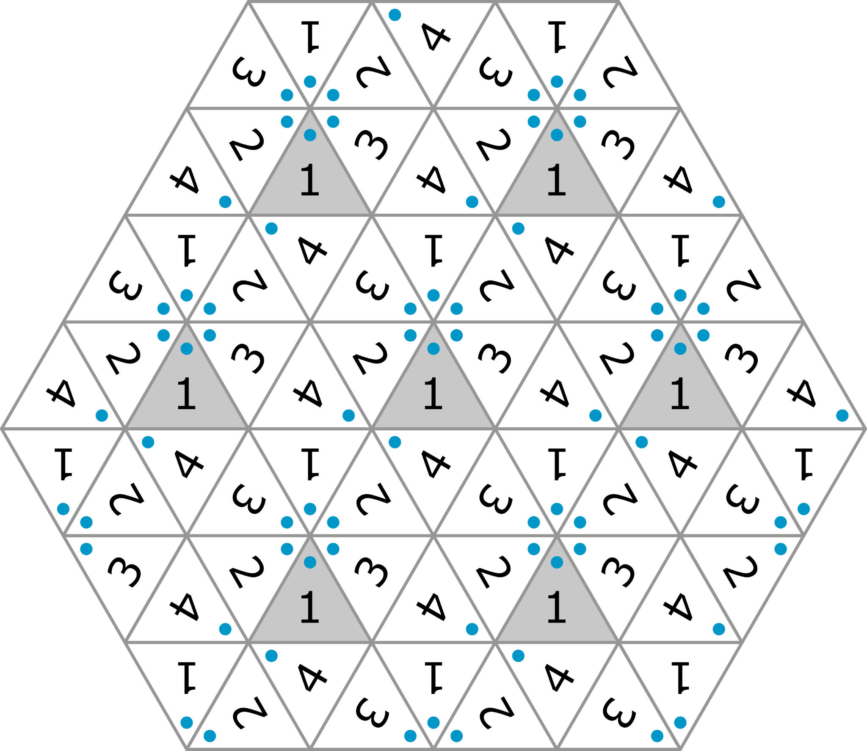

An octahedral die marked like the left image has options to roll as shown in the right 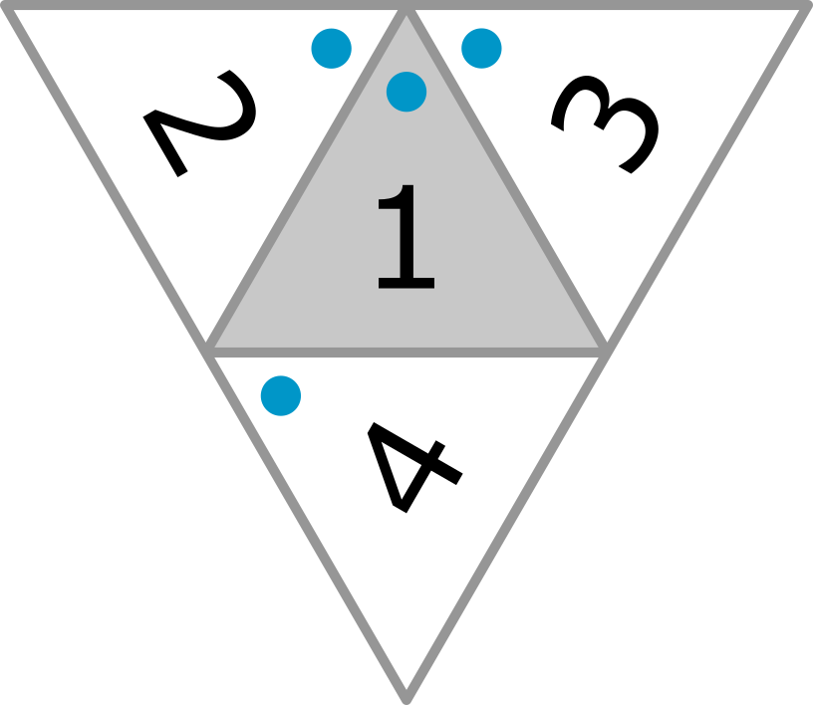image.

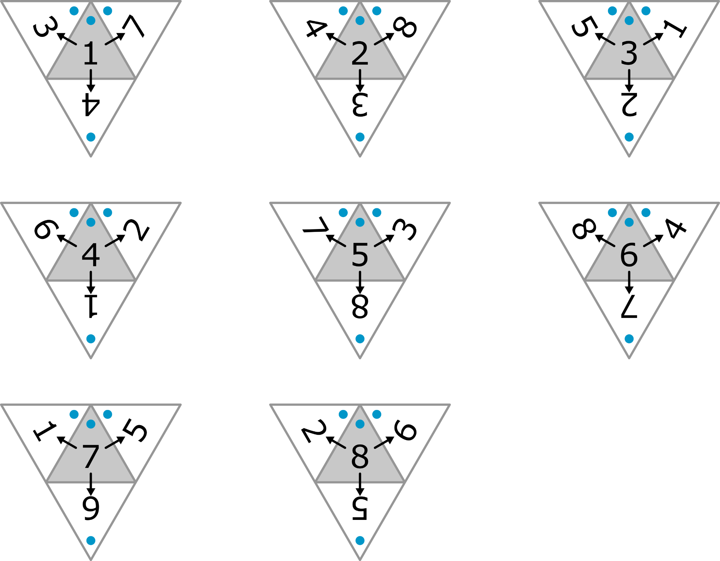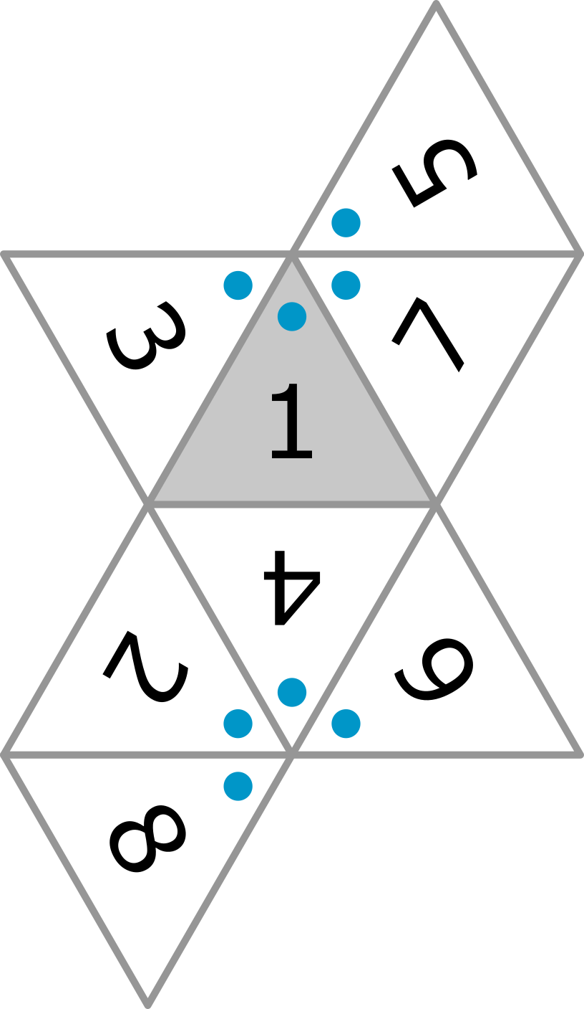

snippets puzzle

This puzzle requires a little bit of writing skill. Open your text editor of choice and write a message that fits with the theme you chose. Hide the clue of this puzzle within the text. (You don’t have to use any cryptography or anything to hide the clue, just write out the clue somewhere in the middle of your message.) Print this when you’re done writing and divide the message into pieces, like a poetic jigsaw. (See also the next example.) Gather the snippets of your jigsaw and put them in the folder (maybe use a paperclip to keep them together).

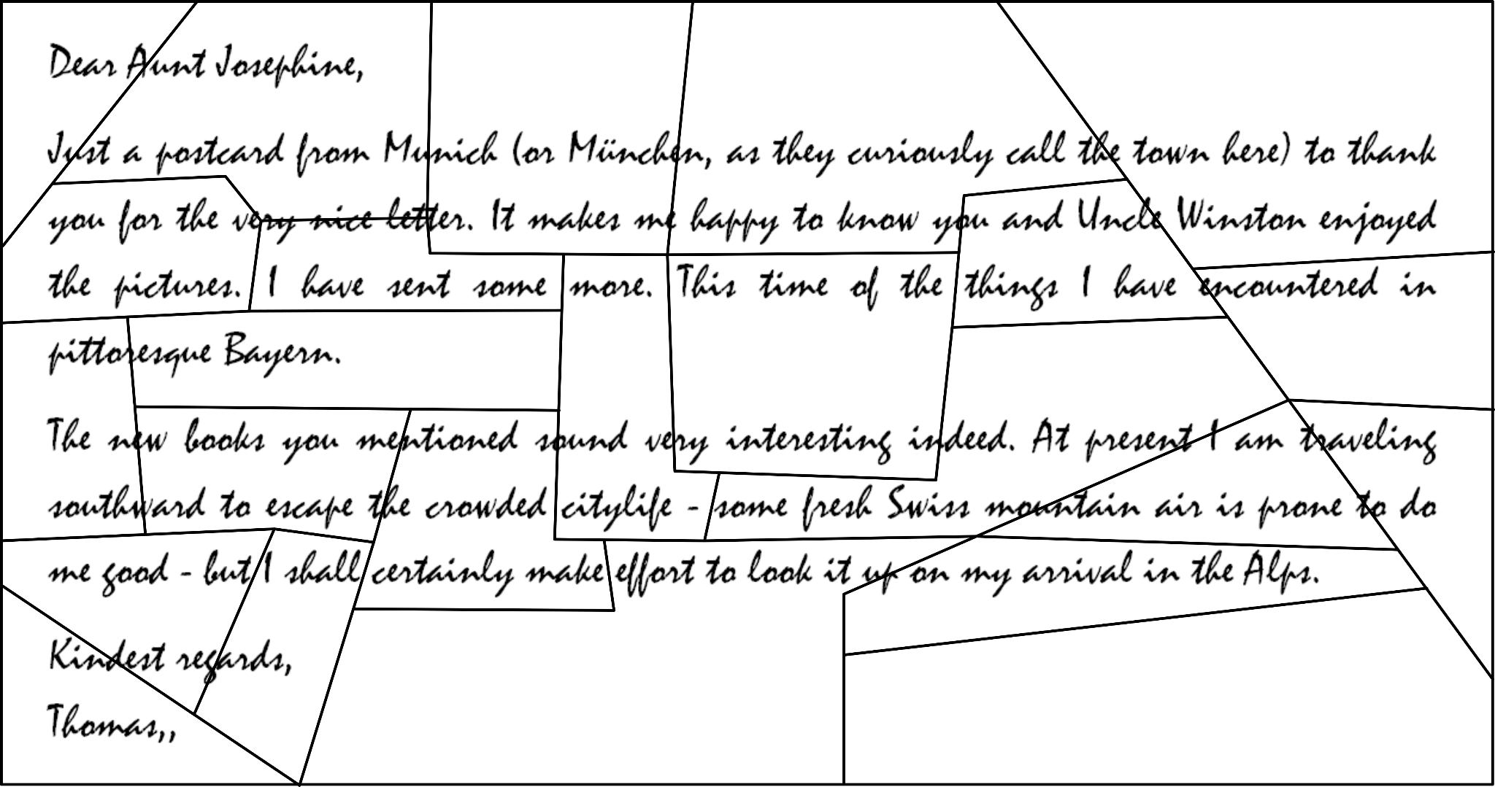

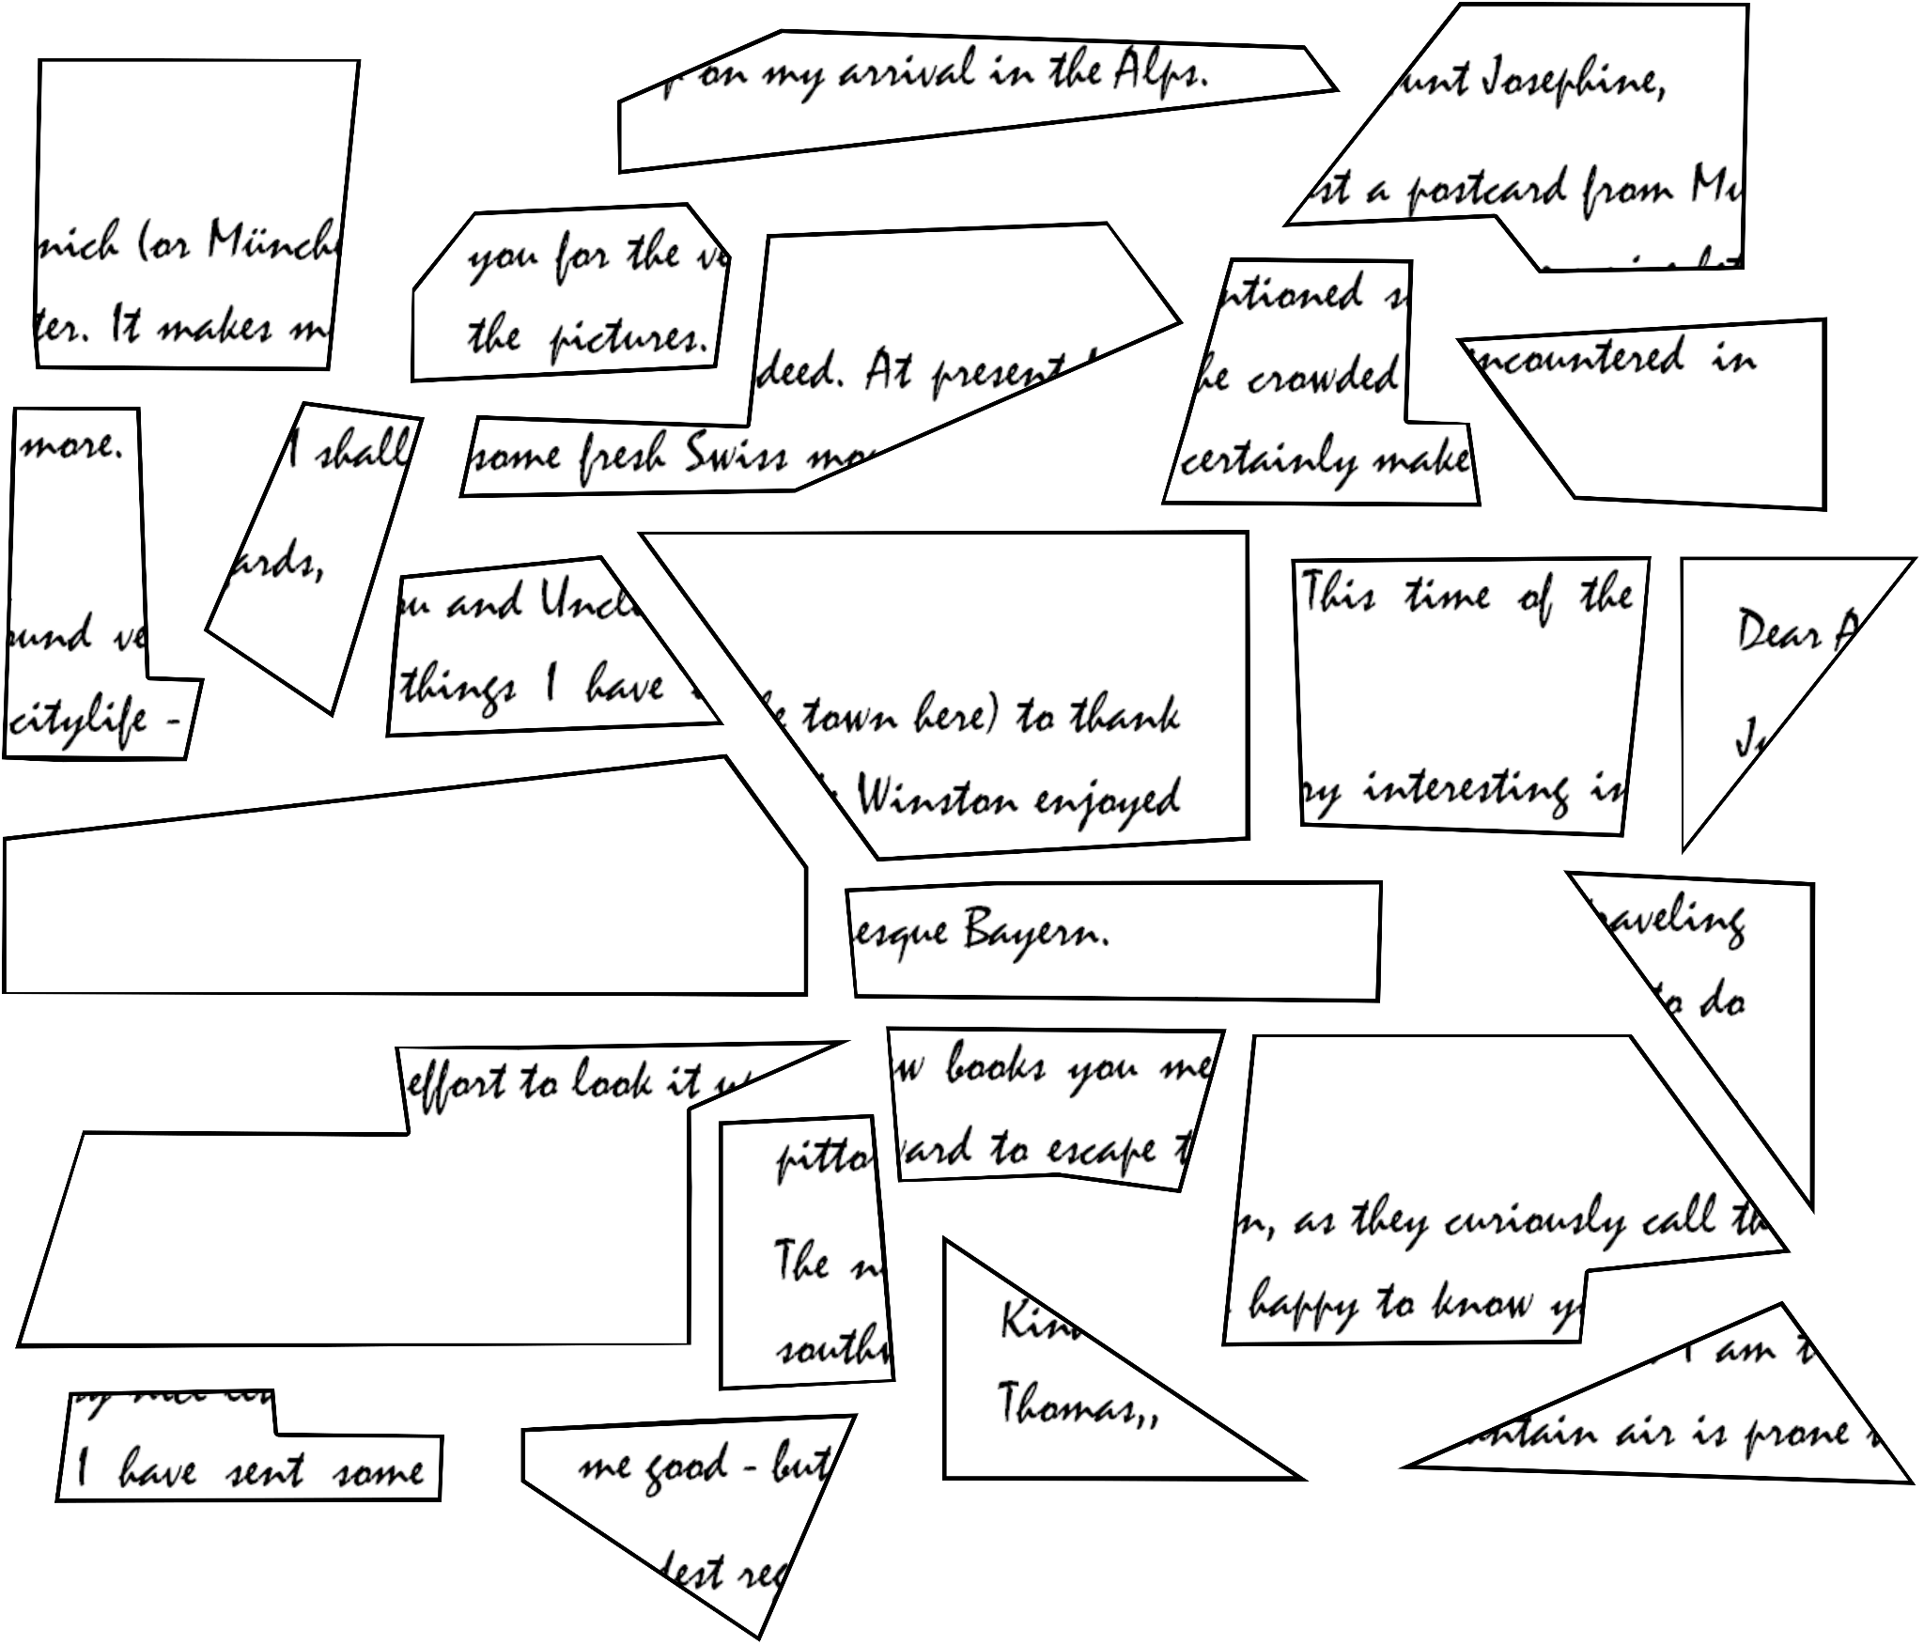

stitching puzzle

The stitching puzzle is best put together using a spreadsheet editor. Write out your clue as a word or a brief sentence. If you opt for a word, you can use the ‘large font’. If you opt for something longer, you should use the ‘small font’. You can find the fonts and their codes in the stitching puzzle template. Copy and paste the letters together with their code to form your word/sentence. (See also the examples in the template.) When a letter is pasted behind another you’ll have to stick its horizontal code behind the other. Don’t forget to put a ‘0’ between the two bits of code. When a letter is pasted underneath another you’ll have to stick its vertical code behind the other. Again, don’t forget to put a ‘0’ between the two bits of code. When you are done, you can remove all the cell borders and print the result. Also print the example for the players and include both printouts in the folder.

6 FINISHING UP

Congratulations! You have reached the final step. All that is left to do, is to check if everything is in the folder, whether you’ve marked the things you needed to mark, whether or not you want to enhance some elements, put the right things into the envelope and seal things off. You can now prepare yourself for the game if you are going to play a role during that game. Then lean back and admire your handiwork. You have just made your very own escape game.